GRADE 7 ACCELERATED · UNIT 1 · LESSON 2
Repeating Decimals to Fractions
Additional Practice 7A.01.02 ANSWER KEY

Use the repeating decimal 0.5888… for questions 1 through 4.
1. Let x = 0.5888… Complete each equation.
 | 10x | = 

 | 100x | = 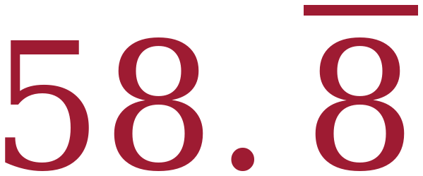
Only one digit repeats, and there is a 5 in front of it that does not. 10 × 0.5888… = 5.888… and 100 × 0.5888… = 58.888…
2. Which two values, when subtracted, leave a whole number? Fill in one bubble.
○ 10x and x
○ 100x and x
● 100x and 10x
58.888… − 5.888… leaves a whole number. Using x instead of 10x would leave 58.888… − 0.5888…, which still has a decimal tail.
3. Use two of the equations from question 1 to find the fraction equivalent of 0.5888… Show the subtraction step.
100x − 10x = 58.888… − 5.888…
90x = 53
x = 
53 is prime, so 53/90 will not simplify.
4. Write 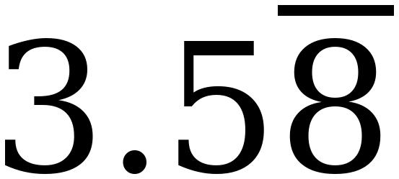 as a fraction and as a mixed number.
Fraction: 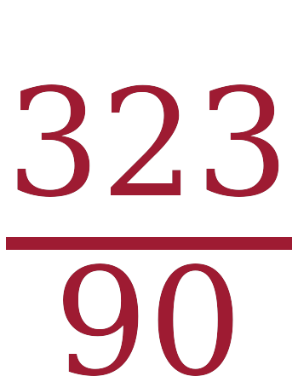 Mixed number: 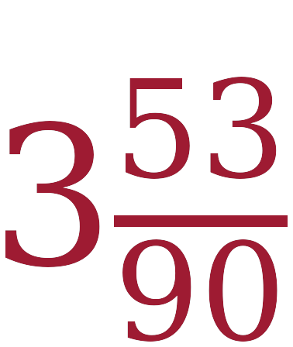
3 × 90 + 53 = 323.

A trail mix recipe uses these amounts: raisins 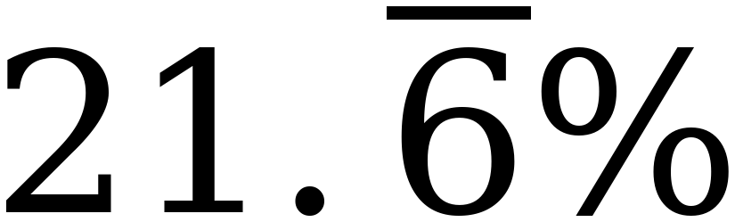, peanuts 5/9, chocolate chips 0.14, and the rest is chex mix.
The bar means the 6 repeats forever.

5. What fraction of the recipe is chocolate chips?

0.14 = 14/100, which simplifies to 7/50.
6. What fraction of the recipe is raisins?

= 0.21666… TWO digits sit in front of the repeat, so move past both: 1000x − 100x gives 900x = 195, and x = 195/900 = 13/60. (100x − 10x would give 90x = 19.5, and 19.5 is not a whole number.)
7. What is the decimal equivalent of the peanuts?

5 ÷ 9 = 0.5555… Use the bar.
8. About what percent of the recipe is chex mix? Round to the nearest whole percent.
9%
Over 900ths: 13/60 = 195/900, 5/9 = 500/900 and 7/50 = 126/900, which total 821/900. Then 900 − 821 = 79, and 79 ÷ 900 = 0.0877…, which rounds to 9%.
For questions 9 and 10, complete the table.
 | Decimal | Percent | Fraction or Mixed Number
9. | 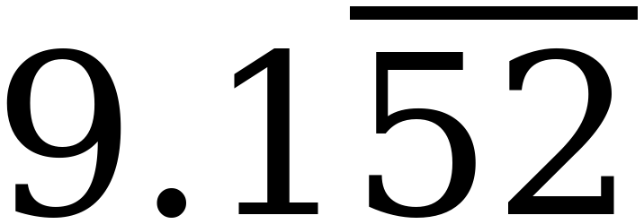 |  | 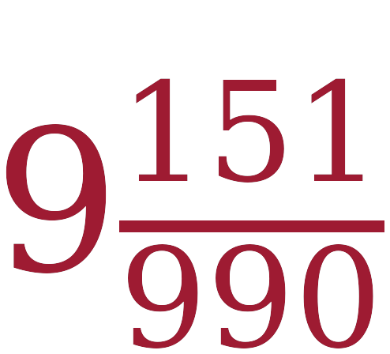
10. |  |  | 
9) For the fraction, one digit does not repeat, so use 1000x − 10x: that gives 990x = 9061, and 9061/990 = 9 151/990.
10) Divide by 100 first: 1.666…% = 0.01666… Two digits sit in front of the repeat, so 1000x − 100x gives 900x = 15, and x = 15/900 = 1/60.

